# Grid Unique Paths

link -- <https://www.interviewbit.com/problems/grid-unique-paths/>

A robot is located at the top-left corner of an **A x B grid** (marked ‘Start’ in the diagram below).

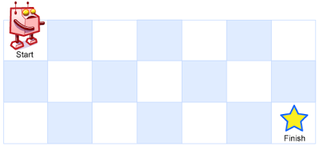

The robot can only move either down or right at any point in time. The robot is trying to reach the bottom-right corner of the grid (marked ‘Finish’ in the diagram below).

How many possible unique paths are there?

*Note: A and B will be such that the resulting answer fits in a 32 bit signed integer.*

**Example :**

Input : A = 2, B = 2

Output : 2

2 possible routes : (0, 0) -> (0, 1) -> (1, 1)

OR : (0, 0) -> (1, 0) -> (1, 1)